Banking system data flow diagram

# Bank Management System DFD Level 0

The Bank Management System DFD level 0 is also known as context diagram. It's supposed to be an abstract view, with the mechanism represented as a single process with external parties.

This DFD for the Bank Management System depicts the overall structure as a single bubble. It comes with incoming/outgoing indicators showing input and output data.

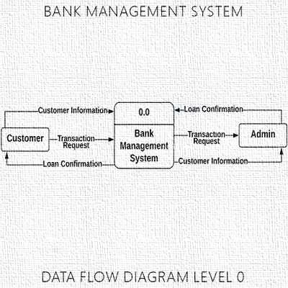

In this data flow diagram, you will see the general process done in Bank Management System monitoring. This will also serve as a guide as you go through the deeper processes of the Bank Management System data flow diagrams.

# Bank Management System DFD Level 1

The content of Bank Management System DFD level 1 must be single process node from the context diagram and is broken down into sub processes.

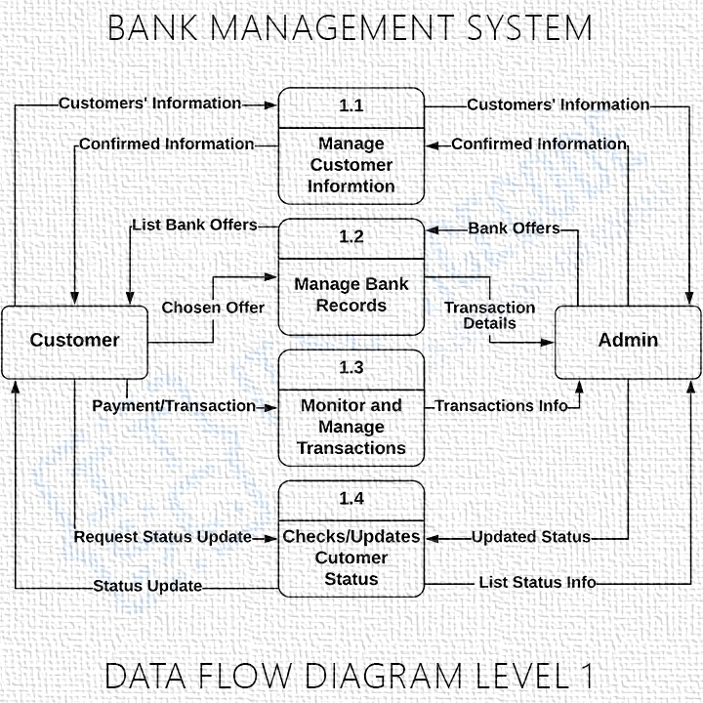

In this level, the system must display or reveal further processing information.

The following are essential data to accommodate:

• Bank Records

• Customers' Information

• Date of Transactions

• Transaction Records

• Employee Records

• Credit/Debit Records

These procedures require information such as record of customers, credits/debits, transactions and employee from which served as the bases for the banking admin to manage the Bank Management System. This type of data is represented by a data store.

With being knowledgeable about the DFD level 1 of the Bank Management System, you will know then its broaden context terms.

Moreover, this may also serve as your reference on how the inputs or data fed on the system. Then you will be also informed about the outputs that the system gives.

These processes shown in the DFD were all based on the concept of Bank Management System.

# Bank Management System Level 2

The Level 2 DFD for the system represents the basic modules as well as data flow between them.

Since the DFD level 2 is the highest abstraction level, its Bank Management System processes must be detailed that is based on the DFD level 1.

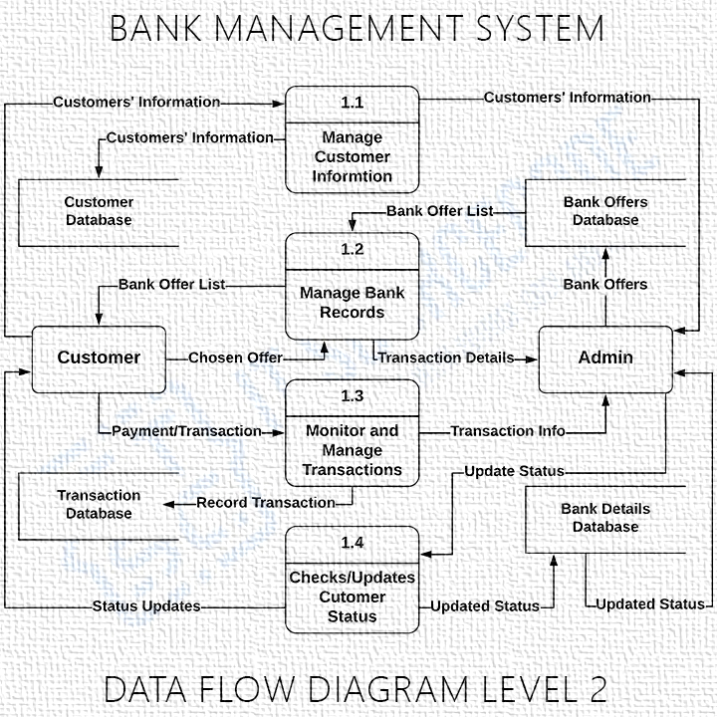

Finally, after figuring the processes given in the system, the user will now have their request being processed.

The Processes that the system should prioritize are as follows:

• Manage Customers Information

• Manage Bank Records

• Checks Date of Transactions

• Update Customers' Status

• Monitor Debit/Credit Transactions

• Manage Withdrawals/Savings

DFD level 2 lets you know the ideas on where does the data inputs goes and inputs comes within the Bank Management System. Considering the dataflow levels mentioned above, you can determine well the importance of breaking the processes into more specific manner.

The presented level not only shows you the detailed processes of system, but also gives you precise destination of the data that flows in the system.

This DFD will also be your references as you make and design your own project DFD levels 0, 1 and 2.